STATEMENT OF ATTENDANCE (Non-Accredited Learning)
Title | RxA’s Trusted Partners in Health Fall Professional Development Virtual Conference 2026 (On-Demand)
Date | September 11 & 12, 2026

Session Title & Presenter | Length | Attended  (Y/N)
The Yearly Booster Seasonal Influenza Vaccine Program  B. Golightly | 2 hours
Pump up the Volume: The Latest in Heart Failure Care  Dr. S Koshman | 1 hour
Defend, Govern, Leverage: The Pharmacist’s Guide to Cybersecurity and Al in 2026  B. Gallant | 1 hour
Beyond Obesity: Dosing and Optimization of GLP-RAs Across Various Pathologies  Dr. R Arora | 1 hour
Cannabis Care: Guidance for Pharmacists  Dr. M Zhang, Dr. B Sproule & Dr. S. Gerges | 1 hour
Insulin in Type 2 Diabetes  S Jin | 1 hour
The Vital Signs We Miss: Why Mattering Matters in Medicine  Dr. A. Pavelich | 1 hour
TOTAL (hours)

I hereby certify that I attended the non-accredited session(s) indicated.
Name | ACP License #
This is your copy. Please save it for your continuing competence portfolio.
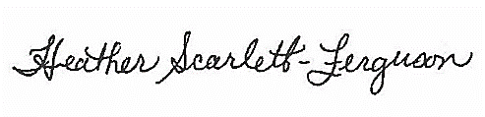

Heather Scarlett-Ferguson, BSP, RPh, MEd, EdD
Director, Professional Development
Alberta Pharmacists' Association (RxA)

