
STATEMENT OF ATTENDANCE
Title | RxA’s Trusted Partners in Health Fall Professional Development Virtual Conference 2026
Event Date | September 11 & 12, 2026
CCCEP Program # | 8007-2026-4220-C-P | Accreditation Period | September 11 – 26, 2026

Session Title |  | CEUs Available | CEUs Claimed
 |  | CEUs Available | Live | On-Demand
Friday, September 11, 2026
 | The Yearly Booster Seasonal Influenza Vaccine Program 2026 - 2027 – B. Golightly | 2.0
Saturday, September 12, 2026
 | Pump up the Volume: The Latest in Heart Failure Care – Dr. S Koshman | 1.0
 | Defend, Govern, Leverage: The Pharmacist’s Guide to Cybersecurity and Al in 2026  – B. Gallant | 1.0
 | Beyond Obesity:  Dosing and Optimization of GLP-RAs Across Various Pathologies – Dr. R Arora | 1.0
 | Cannabis Care: Guidance for Pharmacists – Dr. M Zhang, Dr. B Sproule  & Dr. S. Gerges | 1.0
 | Insulin in Type 2 Diabetes – S. Jin | 1.0
 | The Vital Signs We Miss: Why Mattering Matters in Medicine –Dr. A. Pavelich | 1.0
Total CEU’s Claimed (maximum available = 8.0 CEUs)
*You should claim only the credits that you actually spent in the session or viewed on-demand.
I hereby certify that I attended the sessions and hours for the number of credits indicated.
Name | ACP License #
This is your copy. Please save it for your continuing competence portfolio.
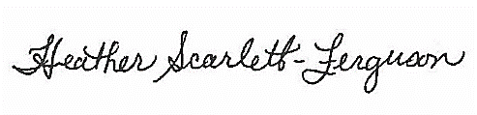

Heather Scarlett-Ferguson, BSP, RPh, MEd, EdD
Director, Professional Development
Alberta Pharmacists' Association (RxA)
780.990.0326

