**Alberta’s Public COVID Program May NOT FULLY PROTECT YOU**

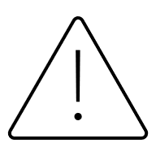CANADA’S NATIONAL IMMUNIZATION EXPERTS (NACI) RECOMMENDS:

* All individuals previously vaccinated and unvaccinated individuals (6 months of age and older) receive a COVID-19 vaccine.

 GOVERNMENT OF ALBERTA LIMITS ACCESS

* COVID-19 Public Health vaccines are now only available through public health clinics - run by Alberta Health Services (AHS).
* You can no longer get COVID-19 public health vaccines at your local pharmacy—even though pharmacists delivered the majority of vaccine doses in recent years.

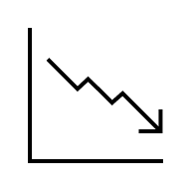 FEWER DOSES WILL BE AVAILABLE

* COVID-19 Public Health vaccines are now only available through public health clinics - run by Alberta Health Services (AHS).
* You can no longer get COVID-19 public health vaccines at your local pharmacy—but privately purchased vaccine is available.

YOU MAY PAY OUT OF POCKET

* Many Albertans will have to pay $80-$110 to get their vaccine.
* Government run public health clinics can’t use your private drug plan to cover the cost.

ALBERTA OFFERS ONE – YOU MAY NEED 2!

Two Doses are recommended for at-risk individuals including: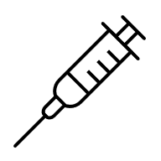

* Adults 80+ years

x 2

* Long-term care and supportive living residents
* People with moderate to severe immunocompromising conditions
* Adults 65–79 years at higher risk

Ask the pharmacist how you can get fully vaccinated.



CONCERNED ABOUT YOUR ACCESS TO CARE

[Protect Patient Access to Pharmacist Provided Care](https://rxa.ca/for-the-public/protect-patient-access/)

**Tell Your MLA | Sign a Petition | Stay Informed**

Visit <https://rxa.ca/for-the-public/protect-patient-access/> today!