The Alberta Government is Increasing the Cost of Seniors Drugs
Starting July 1, 2025, Albertans age 65 and older with Seniors Blue Cross Coverage, will pay more out of pocket for each of their prescription medications, as well as those with Non-Group Blue Cross Coverage younger than 65.
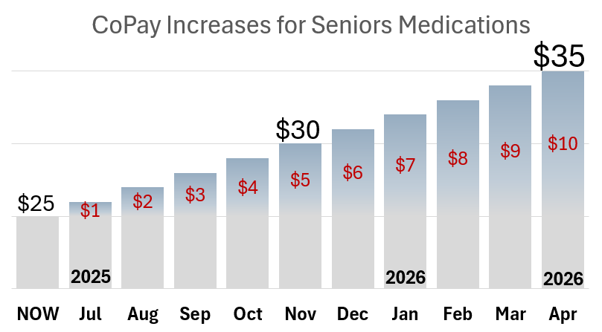

WORRIED ABOUT THE RISING COST OF YOUR PRESCRIPTION MEDICATION? PLEASE CONTACT:
Speak to Your MLA:
Dial 310-0000 and ask to be connected to your MLA
Minister of Assisted Living (Seniors) and Social Services
780-643-6210
scss.minister@gov.ab.ca
Minister of Primary Care and Preventative Health Services
780-427-3665
health.minister@gov.ab.ca

