The Alberta Government is Increasing the Cost of Seniors' Drugs
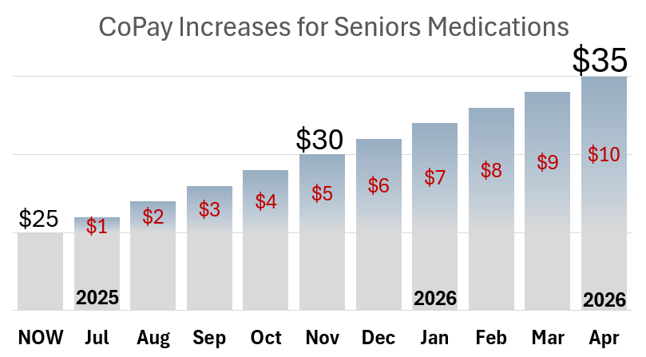
Starting July 1, 2025, Albertans age 65 and older with Seniors Blue Cross Coverage will pay more out of pocket for each of their prescription medications, as well as those with Non-Group Blue Cross Coverage younger than 65.


WORRIED ABOUT THE RISING COST OF YOUR PRESCRIPTION MEDICATION?
Protect Patient Access to Pharmacist Provided Care
Tell Your MLA | Sign a Petition | Stay Informed
Visit https://rxa.ca/for-the-public/protect-patient-access/ today!

